**Blockchain Technology Report**

**Projeto** **STAGIHO-BD** (**S**oluções **T**ecnológicas **A**plicáveis ao **G**erenciamento de **I**nformações **H**ospitalares **O**stensivas com ***B****ig* ***D****ata*)

**Professors:**

Prof. Dr. Adilson Marques da Cunha

Prof. Dr. Luiz Alberto Vieira Dias

**Collaborators:**

Lineu Alves Lima Filho

Paulo Diego Barbosa da Silva

Breslei Max Reis da Fonseca

Juliana Forin Pasquini Martinez

Leonardo Guimarães dos Santos

SÃO JOSÉ DOS CAMPOS

2018

Contents

**1 Objective** **2**

**2 Hyperledger Fabric** **2**

2.1 Building Your First Network - Hyperledger Fabric 3

2.1.1 Install prerequisites 3

2.1.2 Run Fabric-Samples 5

2.1.2.1 Command generate 6

2.1.2.2 Command UP 7

2.1.2.3 Command down 8

**3 Ethereum** **9**

**4 Resources to Learn Blockchain** **10**

**5 Blockchain Challenges** **10**

**6 References** **11**

## **1 Objective**

The main objective of this report is to evaluate Blockchain solutions. It will help members of the STAGIHO-DB Project to implement a Proof of Concept (PoC) of Blockchain during Sprint 3.

## **2 Hyperledger Fabric**

Hyperledger is an open-source development project under the Linux Foundation, according to Brian Behlendorf (Executive Director, Hyperledger) "Hyperledger is an open sourced community of communities to benefit an ecosystem of Hyperledger based solution providers and users focused on blockchain related use cases that will work across a variety of industrial sectors." [3]

Hyperledger Fabric is a blockchain framework implementation and one of the Hyperledger projects, it was initiated by Digital Asset and IBM, and has now emerged as a collaborative cross-industry venture which is currently hosted by The Linux Foundation. Among the several Hyperledger projects, Fabric was the first one to exit the “Incubation” stage and achieve the “Active” stage in March 2017. [4] [15]

For businesses private transactions and confidential contracts that are essential, however, traditional blockchain networks can’t support them. Hyperledger Fabric was designed to be a modular, scalable and secure foundation for offering industrial blockchain solutions.[15]

The modular architecture of Hyperledger Fabric separates the transaction processing workflow into three different stages [16]:

* Smart [contracts](https://www.investopedia.com/terms/s/smart-contracts.asp) called chaincode that comprise the distributed logic processing and agreement of the system; [17]
* Transaction ordering;
* Transaction validation and commitment.

Figure 1 illustrates the Transaction lifecycle in v1.0 of Hyperledger Fabric. It offers multiple benefits – reduced number of trust levels and verification that keeps the network and processing clutter-free, improved network scalability, and better overall performance.

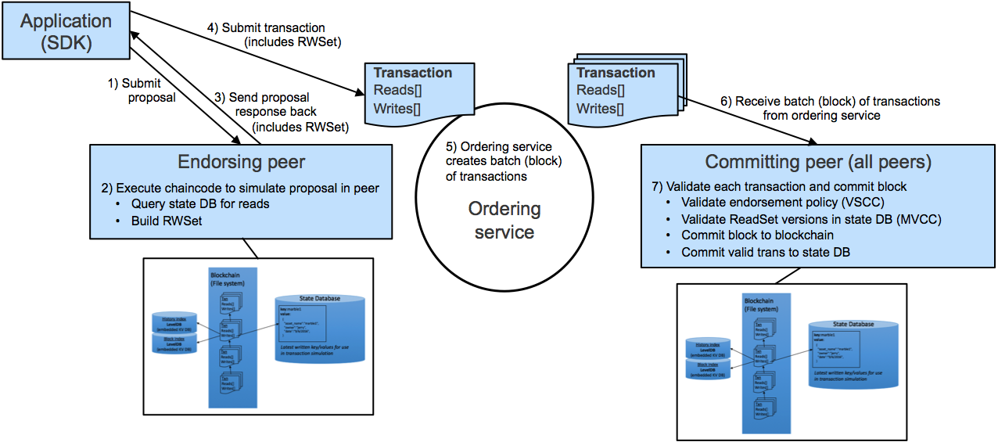

Figure 1 -Transaction lifecycle in v1.0 of Hyperledger Fabric [16]

### **2.1 Building Your First Network - Hyperledger Fabric**

It's possible to build a Network of Hyperledger Fabric and execute it following the tutorial that is found on the Hyperledger website. The build your first network (BYFN) scenario provisions a sample Hyperledger Fabric network consisting of two organizations, each maintaining two peer nodes, and a "solo" ordering service. [10]

Following are the steps performed using WINDOWS 7:

#### **2.1.1 Install prerequisites**

In the first step we installed tools needed such as cURL, Docker and Docker Compose and configure them. After that, it is necessary to install the samples, binaries and docker images.

The video-tutotal [14] explains how to install and use Docker ToolBox for windows. Docker Toolbox provides a way to use Docker on Windows systems that do not meet minimum system requirements for the Docker for Windows app. Figure 2 shows the virtual machine being created and Figure 3 shows the Docker Quickstart Terminal 2.

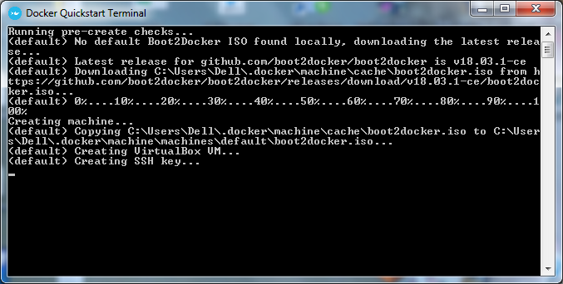

Figure 2 - Docker Quickstart Terminal

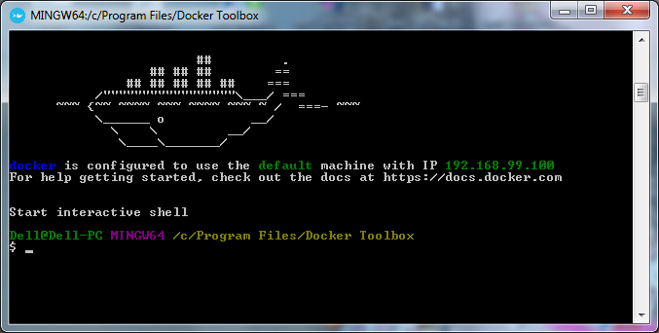

Figure 3 - Docker Quickstart Terminal 2

Figure 4 - Clone fabric-sample.git shows the Git Extension Tool Screen and the Figure 5 shows that the files have been successfully cloned.

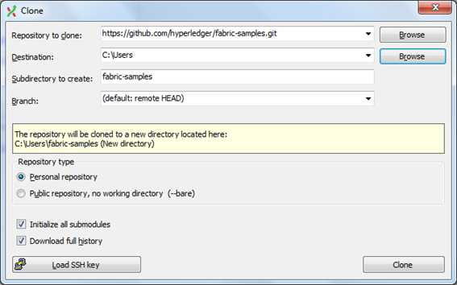

Figure 4 - Clone fabric-samples.git

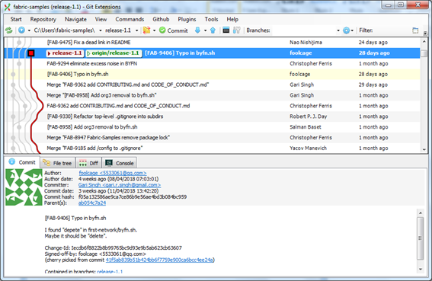

Figure 5 - Files Clone fabric-samples.git

#### **2.1.2 Run Fabric-Samples**

There is a fully annotated script - byfn.sh to bootstrap a Hyperledger Fabric network containing 4 peers representing two different organizations, and an orderer node [10]. Figure 6 illustrates the byfn.sh script.

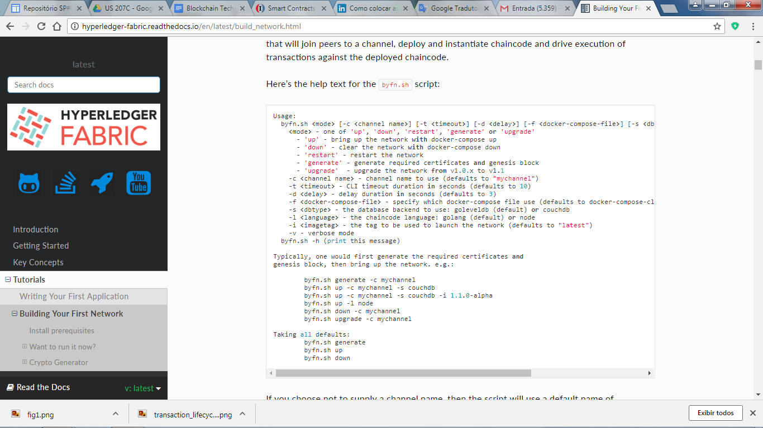

Figure 6 - byfn.sh script [10]

The following commands have been executed:

##### **2.1.2.1 Command generate**

This command generates all of the certificates and keys for Fabric-Samples various network entities, the genesis block used to bootstrap the ordering service, and a collection of configuration transactions required to configure a [Channel](http://hyperledger-fabric.readthedocs.io/en/latest/glossary.html#channel). [10]

Figure 7 shows the command to generate the Network and figure 8 shows the question after the command generated. [10]

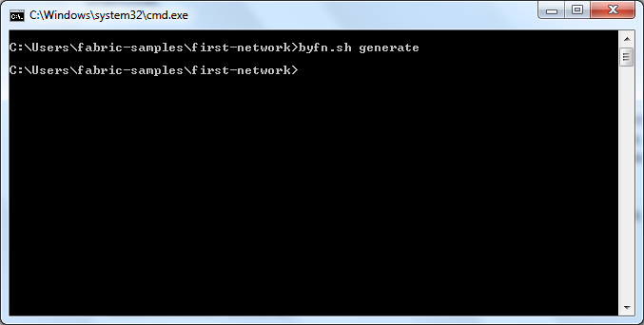

Figure 7 - Command to generate the Network

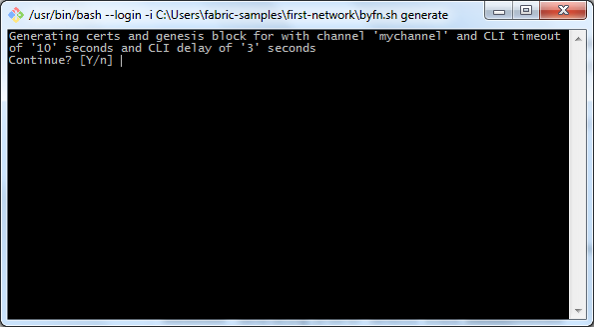

Figure 8 - Question after Command to generate Network

##### **2.1.2.2 Command UP**

This command compiles Golang chaincode images and spin up the corresponding containers. Go is the default chaincode language, but it also supports Node.js chaincode. [10]

Figure 9 shows the command to Bring Up the Network and figure 10 shows the question after the command up. [10]

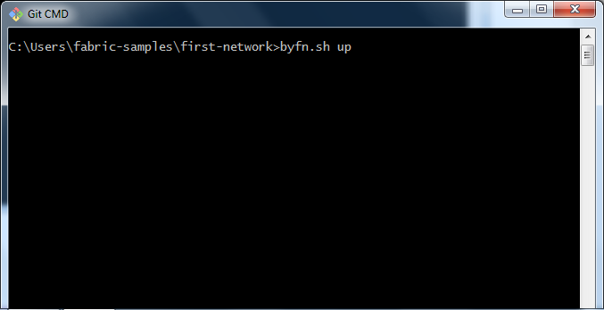

Figura 9 - Command up

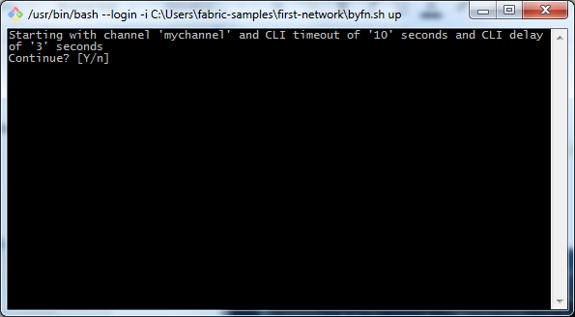

Figure 10 - Question after Command up

##### **2.1.2.3 Command down**

This command extinguishes the containers, remove the crypto material and four artifacts, and delete the chaincode images from your Docker Registry. [10]

Figure 11 shows the command to Bring Down the Network, figure 12 shows the question after the command down and figure 13 illustres the first network being extinguished. [10]

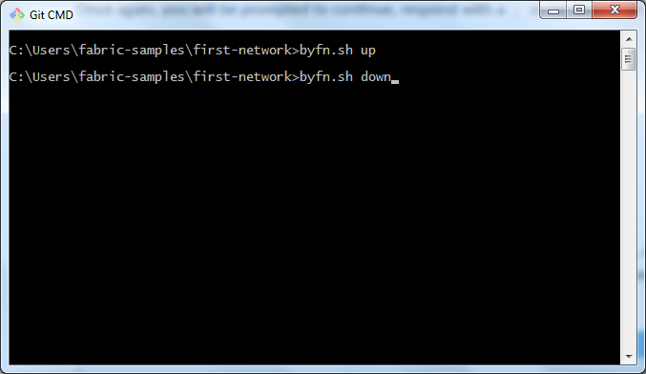

Figura 11 - Command down

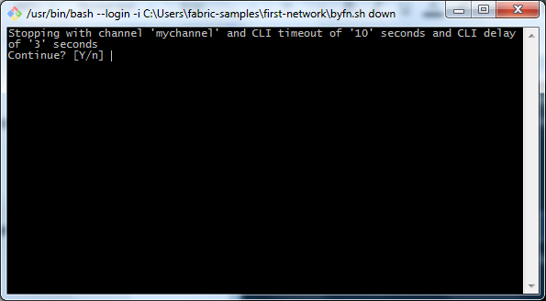

Figura 12 - Question after Command up

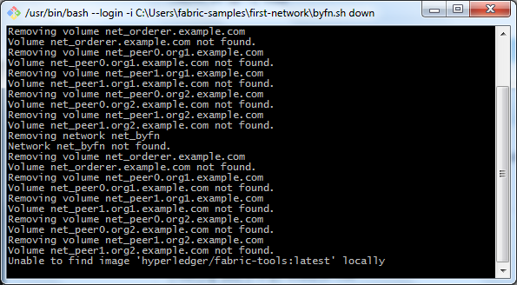

Figura 13 - First-network down

## **3 Ethereum**

According to Macdonald, Liu-Thorrold and Julien [6], after comparing five different blockchain platforms: Ethereum, IBM Open Blockchain (OBC), Intel Sawtooth Lake, BlockStream Sidechain Elements, and Eris, they found that [Ethereum](https://www.ethereum.org/) is the most suitable platform.

Microsoft Azure [9] offers three choices of platforms of blockchain: Corda, Ethereum and Hyperledger Fabric.

## **4 Resources to Learn Blockchain**

A Developer named Savjee published two video-tutorials [7], [8] explaining **how to implement blockchain with JavaScript**. The videos are very well-explained and practical.

The Blockchain Essentials course [2], available at Cognitive website, is mainly based on theory. Although it has a practical laboratory that uses a sandbox, the instructions are outdated since the technology is constantly evolving [6].

ANADIOTIS [11] presents some attempts to implement blockchain in database solutions. The latest solution is a joint of BigchainDB with MongoDB. This partnership was necessary as BigchainDB has no query language.

With the shutdown of the Inter-Planetary DB (IPDB) project [12], **Bigchain Testnet** [13] took place. It is a blockchain development/test environment that people can use it, reducing the difficulties in starting a blockchain environment from scratch.

## **5 Blockchain Challenges**

Don Tapscott cited in this book [18] some of the challenges blockchain technology will need to overcome in the near future:

* The technology is still in development stage;
* The energy consumed is unsustainable;
* Organizations will be resistant to its implementation;
* The job market will go through changes;
* Privacy needs to be regulated to avoid surveillance;
* Criminal organizations may use it.

## **6 References**

[1] ВаНаоВ, Иван. **1- What is Hyperledger Fabric.** 2017. Disponível em: <https://www.youtube.com/watch?v=7EpPrSJtqZU>. Acesso em: 30 abr. 2018.

[2] COLE, Ant; GORMAN, Dave. **Course: Blockchain Essentials.** 2017. Disponível em: <https://cognitiveclass.ai/courses/blockchain-course/>. Acesso em: 30 abr. 2018.

[3] Edureka. **What is Hyperledger?**. 2017. Disponível em: <<https://www.youtube.com/watch?v=Y177TCUc4g0>>. Acesso em: 04 mai. 2018.

[4] The Linux Foundation. 2018. Disponível em: <<https://www.hyperledger.org/projects/fabric>>.

[5] ВаНаоВ, Иван. **Hyperledger Fabric - build first network.** 2018. Disponível em: <https://www.youtube.com/playlist?list=PLjsqymUqgpSTGC4L6ULHCB_Mqmy43OcIh>. Acesso em: 06 maio 2018.

[6] Macdonald, M & Liu-Thorrold, Lisa & Julien, R. (2017). **The Blockchain: A Comparison of Platforms and Their Uses Beyond Bitcoin.** 10.13140/RG.2.2.23274.52164.

[7] SAVJEE. **Creating a blockchain with Javascript (Blockchain, part 1).** 2017. Disponível em: <https://www.youtube.com/watch?v=zVqczFZr124>. Acesso em: 06 maio 2018.

[8] SAVJEE. **Implementing Proof-of-Work in Javascript (Blockchain, part 2).** 2017. Disponível em: <https://www.youtube.com/watch?v=HneatE69814>. Acesso em: 06 maio 2018.

[9] BLOCKCHAIN on Microsoft Azure. 2018. Disponível em: <https://azure.microsoft.com/en-us/solutions/blockchain/>. Acesso em: 06 maio 2018.

[10] Hyperledger. 2017. Building Your First Network. Disponível em:

<<http://hyperledger-fabric.readthedocs.io/en/latest/build_network.html>>. Acesso em: 04 maio 2018.

[11] ANADIOTIS, George. **How to use blockchain to build a database solution.** 2017. Disponível em: <https://www.zdnet.com/article/blockchains-in-the-database-world-what-for-and-how/>. Acesso em: 06 maio 2018.

[12] INTER-PLANETARY DB. 2018. Disponível em: <https://ipdb.io/>. Acesso em: 06 maio 2018.

[13] BIGCHAIN Testnet. 2018. Disponível em: <https://testnet.bigchaindb.com/>. Acesso em: 06 maio 2018.

[14] Diedrich, Cristiano. Docker ToolBox. 2015. Disponível em: <<https://www.mundodocker.com.br/docker-toolbox/>>. Acesso em: 08 maio 2018

[15] INVESTOPEDIA. [Hyperledger Fabric Definition. 1018. Disponível em:](https://www.investopedia.com/terms/h/hyperledger-fabric.asp#ixzz5F65BlpsL) <<https://www.investopedia.com/terms/h/hyperledger-fabric.asp#ixzz5F65BlpsL>>. Acesso em: 10 maio 2018.

[16] [Cocco](https://www.linkedin.com/in/sharon-weed-cocco-a4a19b69/), [S. W.;](https://www.linkedin.com/in/sharon-weed-cocco-a4a19b69/)  [Singh, G.](https://www.linkedin.com/in/garisingh/) 2018. Top 6 technical advantages of Hyperledger Fabric for blockchain networks. Disponível em: <<https://www.ibm.com/developerworks/cloud/library/cl-top-technical-advantages-of-hyperledger-fabric-for-blockchain-networks/index.html>>. Acesso em:10 maio 2018.

[17] INVESTOPEDIA. 2018. Smart Contracts. Disponível em: <https://www.investopedia.com/terms/s/smart-contracts.asp>

[18] Tapscott, D., & Tapscott, A. (2016). *Blockchain revolution: how the technology behind bitcoin is changing money, business, and the world*. Penguin.